Midterm Project Documentation
Project Topic: Simple Interactive Game
Han-Chung Lien (Alan) email: hl367@duke.edu

Project Concept Overview
For this project, I would like to build a simple interactive game by using the materials learned from Media & Art 206 week 1 to week 3's content. It is hard to classify the category of this game, the closest category I could think of (base on the classification of Steam) might be Casual. The goal of this game is to pass every level, to do that, the player will need to explore the elements that appeared on their window and use their creativity to solve the puzzles. This documentation will briefly introduce some of the plot designs and game mechanisms. I'll briefly walk through the game in the technology overview part.

Game Mechanisms

The player might be confused for a short period when they see the user interface, but I'm sure that they will soon understand what to do with this game since the game logic is simple. The player will notice that they are stuck in a main menu-like interface, if they click around the objects appeared on the interface, they will find out that some of the objects are interactable. Maybe clicking, maybe dragging, the players will need to use their creativity and try things out in order to proceed. However, this game will not only be about puzzle solving, it will also include some miner game inside the major game. I planned to include the Space Invader, and the Snake (if I have the time). Taking into account the complexity, my coding ability, and the time I have, the game size will be quite limited. I am not planning to finish making the whole game, all I planned to do is to make the introduction chapter ( or the first chapter) and see how it work (either for me as the maker, and for the players.).

Game Settings

For this game, there will be no background setting or story needed. The player will start the game with a main menu style interface. In that interface, the start button will be sealed, the primary goal for the players in this phase will be finding a way to release and use the start button. Besides the start button, there are also things like an alien-ship-shaped setting button, a character that is fishing and sitting on a floating island, the私には難しい(means this is so hard for me) label, etc…
To the players, those items will seem to be not related at all. However, they will need to interact or combine the items in order to beat the game.

Visualization

How will our game integrate visualization? I will most likely to take the character I designed for my old game, get some copyright-free photos from the internet, create some images using graphic design software like Adobe Photoshop or Aseprite, and I will code the rest.
Due to the limited time, I don't have time to find appropriate images that maintain the overall style. So this game might display multiple kinds of art styles, including but not limited to pixel art, actual pictures, animated graphics, and hand-drawn images.

The Overall interface

Attached below is some of the “must include” element of my design,
The design is like what players would normally expect for the main menu of the game, the name of the game on top, with the buttons of start and setting below.

This is just the rough draft, the empty space is totally open to decorations that may enhance the overall visual effect.
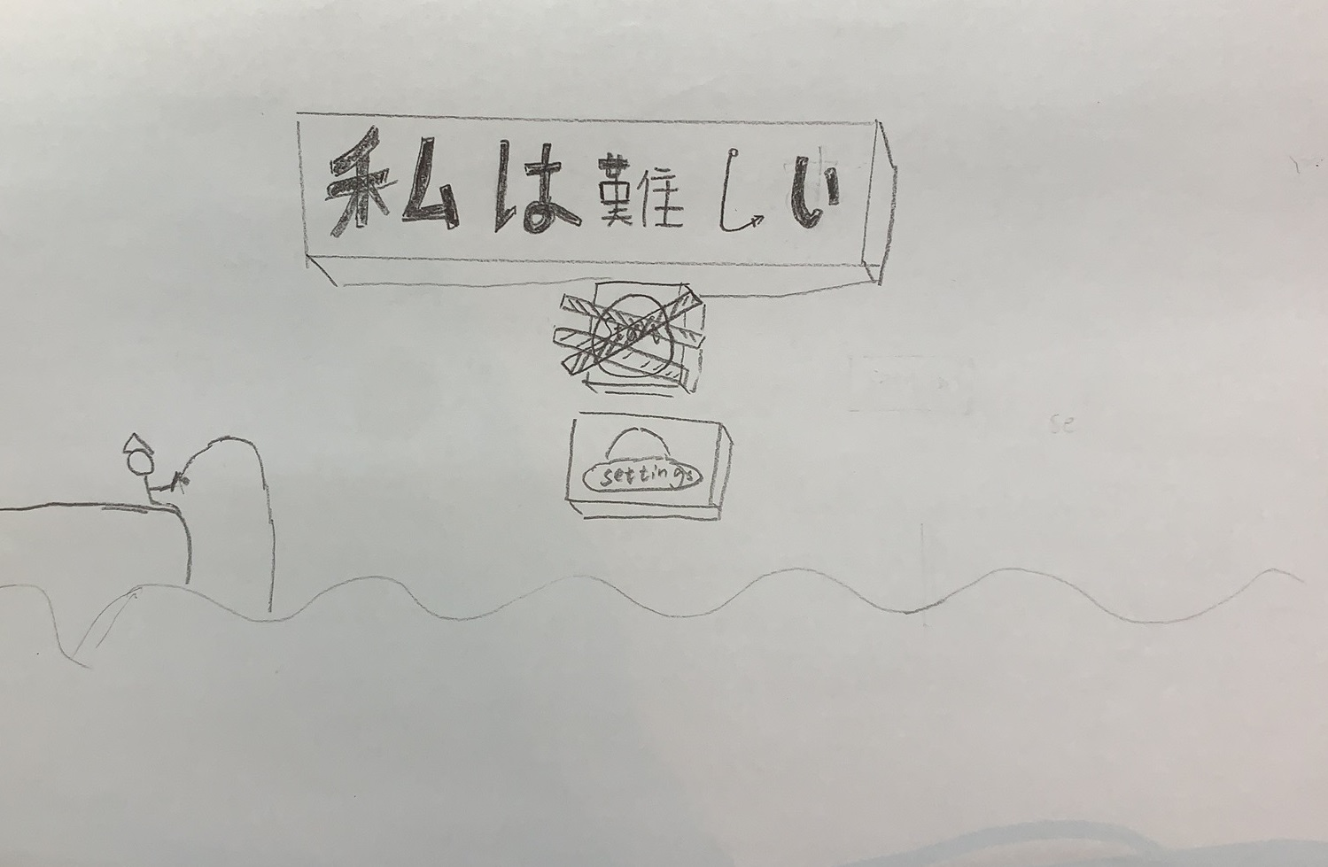
Figure1. The Overall interface

Start Button that is sealed

The player will notice the word written on the button, along with the barrier that blocks it.
The player would very likely to click on it. (And notice that it’s not working)
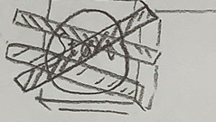
Figure2. Start Button

Setting Button

The setting button is made in the shape of a space ship. It is not a normal thing to do, and the player might feel weird about it, but they will probably still click it to see what is going to happen.
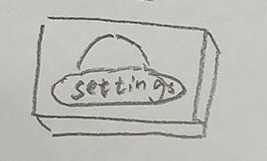
Figure3. Setting Button

(Will be adding more after the final product is made)

Technology Overview & Game Walkthrough

For this scene, there are many objects that need to be built:
The start button
The setting button
The label
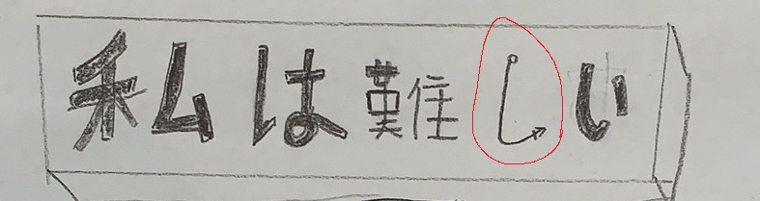
The Fishing rod
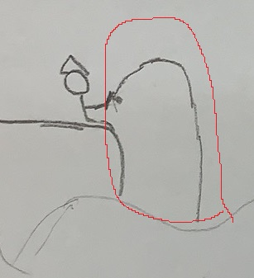

And the wave (doesn’t really need to be an object though) (Will probably code it through trigonometry functions)
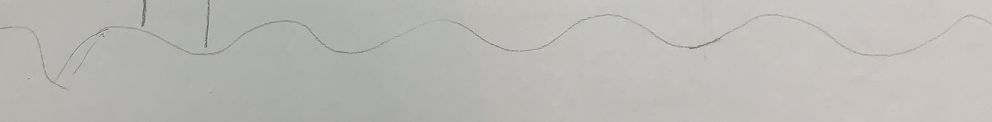

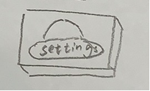
The player will start by clicking the start button, not working, so they will try to click on other things. If they click on the setting button, the button will shake. When being clicked
multiple times, the space ship on the button will fall into the sea. (Gravity function)

Now, the correct action for the players is to click the fishing rod, the fishing rod will
be pulled up a little bit, and the player will notice that there is no hook on the rod.
By clicking and dragging, the player may take the fishing rod from the character,
(Attraction, Repulsion, and Damping → glm:: functions)

They’ll now need to find the hook for the rod, which is
actually one of the Japanese characters. Put the rod on the
Japanese characterし, and they’ll get a complete fish rod.
(Draw a new image)
Give the character the new rod, and he/she will start fishing.
Option 1:
Create a Snake game (I don’t know how to code it yet, but will look it up if I am going to make it) under the surface of the sea (the rod will be the snake), if the player reached certain point, the rod will hook on the space ship and drag it out. (ypos += int ?)
Option 2:
Get the space ship directly.

After getting the space ship, the space ship will float on the surface of water → aliens will appear on the screen (space invader), shoot and defeat the aliens. After defeating the aliens, shoot on the start button, the barrier will fall down. (Gravity function)

Eventually, the player may click on the start button, and something like to be continued will appear.

To ensure everything happens correctly and is in the order I want, I will need to use many true/false Boolean.

UI/UX (Very brief)
(Will be changed after the final product is made)
No matter what kind of game it is, to ensure the gaming experience for players, the top priorities will always be the fluency of the game (which would be accomplished through implementing techniques), the contents, and the art designs. While some of these contents would be specifically included in the User Journey Part, this part will focus on some of the illustration and designation for different components of the game.
As a creative casual game, using pixel style from the beginning till the end will be a very good choice. However, as long as the players will not feel uncomfortable when playing, the artistic style is really not limited (especially when don’t have a lot of time to design the art work). During the proposal writing phase, I cannot predict what I will use eventually, so I may only talk about my requirements for the image.

User Journey
In this part, we will follow the order of how players might experience the entire game and utilize an “Event---feeling---possible thoughts (reactions) of players” format to demonstrate this part.

USER | A DKU student who is new to horror games but has gaming experience
Stage | Before Starting playing the game | Confused about what is going on after testing the button | Exploration | Play the mini game(s) | Ending
Activity | Seeing the interface | After failed to enter the game,  Confused. | Start to realize that other objects are interactable. | After solving some puzzles, start to play the mini games. | Figur out that the start button will not take the player to the next level
Possible  Expectation | Expecting to know “what” the game is about and “How to play” after clicking the start button | Expect the buttons to function the way it should be. | Click other objects, try to find the one that works | Expect the mini game(s) to work properly | Expect to see more content
Possible  Experience | Realized that the start may not be clicked, being to be confused. | Noticing that none of the buttons actually function the way it supposes to be. | Confused, but start to know what this game is about. | Find it creative/not creative | Like it/Don’t like it
Possible  Problem | Thought that it’s a bug, quit the app | The player dislikes the game and quit. | The player somehow just doesn’t know how to solve the puzzle. | - Bugs  - Too hard/easy | Think the ending is too normal/boring  Think the author is lazy.
Possible  solution | Add narrator and words that explain the situation | Add narrator and words that explain the situation might also help with this situation.  The dialog needs to be interesting | Create a Hint function. | Rewrite the Code to make it easier/harder  Debug | Spend more time working on it to make the game closer to complete.

(Will write it after I finish making the game)
Prototyping and Developing
Conclusion

